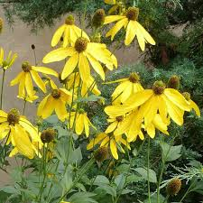
Sochan/ Cutleaf Coneflower

* Full sun to part shade *thrives in wet environments *delicious edible *supports a wide variety of insects *tall perennial *deer resistant

